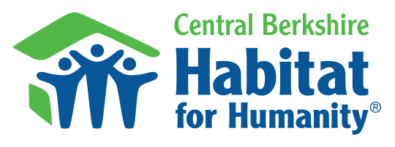
FOR IMMEDIATE RELEASE
April 6, 2022

Contact:
Erin O’Brien
Land & Permitting Manager
Central Berkshire Habitat for Humanity
Office: 413.442.3181 x8
Cell: 856.304.8703
planner@constructberkshire.org

Habitat for Humanity is building in South County!

Great Barrington, MA – Spring is here and Central Berkshire Habitat for Humanity is working on a newly purchased property located at 40 Grove Street in Great Barrington. This home, built in the late 1800s, is being renovated as the first step to Habitat providing affordable homeownership in South County. The Town of Great Barrington and its Affordable Housing Trust chose to sell this 3-bedroom home to Habitat as part of their ongoing efforts to keep the area affordable for those hard-working families that work in the area. After renovations, this home will be made available for sale using a lottery system later this year according to the Dept. of Housing & Community Development standards.

The lottery system gives all eligible applicants an equal chance of purchasing the home. Habitat will have trained volunteers to help people interested in purchasing this home available throughout the process.

With rental costs rising, opportunities like this one give people a chance to own a home and build wealth for their families while having an affordable payment.

Habitat can only offer homes at an affordable price with the help of generous volunteers and contractors from all over South County so the call for those interested in helping out has begun. Habitat brings people together to build homes, communities, and hope, and to do that, we need to develop a core of Habitat Champions group that will be able to shape the work we do in South County. Whether skilled or those who just want to learn and be a part of building something bigger than themselves, Habitat welcomes one and all to the team.

In March, Habitat held an Open House for volunteers at the home on Grove Street as a first step to getting to know the neighbors and give those interested a taste of who Habitat is and what we do. In the past few weeks, volunteers have helped to shore up the building for safety, clean out the home’s contents, and remove sheet rock. In the coming month, the foundation will need to be stabilized so that volunteer crews can begin the renovation work needed.

This project is just the first of many projects here in Great Barrington and Housatonic. In addition to this home renovation, Habitat is working with the Town’s Affordable Housing Trust to build up to 20 affordable homes on a piece of land on North Plain Road in Housatonic.

We believe that everyone should have a decent place to call home. Together, we achieve that vision, when we all come together sharing our traditions and customs to build a better community.

We invite anyone interested to check out our Volunteer page on our website at BerkshireHabitat.org Or, call us at 413.442.3181 to get involved. We are very excited to be moving Habitat forward with work in South County and look forward to a productive year ahead.

Photo included: Teamwork makes the dream work. Volunteers at 40 Grove Street help Habitat for Humanity begin the rehab work needed to restore this 3-bedroom home.
